Минобрнауки России
Федеральное государственное бюджетное образовательное
учреждение высшего образования
НИЖЕГОРОДСКИЙ ГОСУДАРСТВЕННЫЙ ТЕХНИЧЕСКИЙ УНИВЕРСИТЕТ
ИМ. Р.Е. АЛЕКСЕЕВА
ИНСТИТУТ РАДИОЭЛЕКТРОНИКИ И ИНФОРМАЦИОННЫХ ТЕХНОЛОГИЙ

Курс “Сети и телекоммуникация”
Отчет по лабораторной работе №1

Выполнил: Слабунов И.Н.
Проверил: Гай В.Е.

Нижний Новгород 2020
Задание на работу:
9 Вариант
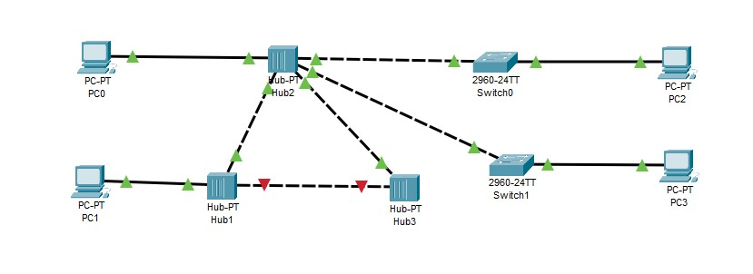
Компьютер PC0 имеет IP-адрес 128.64.121.1.
Компьютер PC1 имеет IP-адрес 128.64.121.2.
Компьютер PC2 имеет IP-адрес 112.65.127.7.
Компьютер PC3 имеет IP-адрес: 111.65.121.6.
Структура сети:
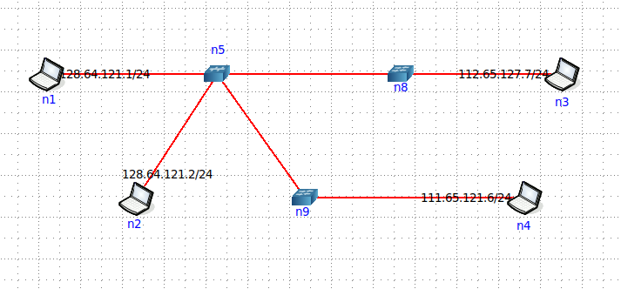

Доказательства работы:
Между компьютерами одной подсети проходит ping.
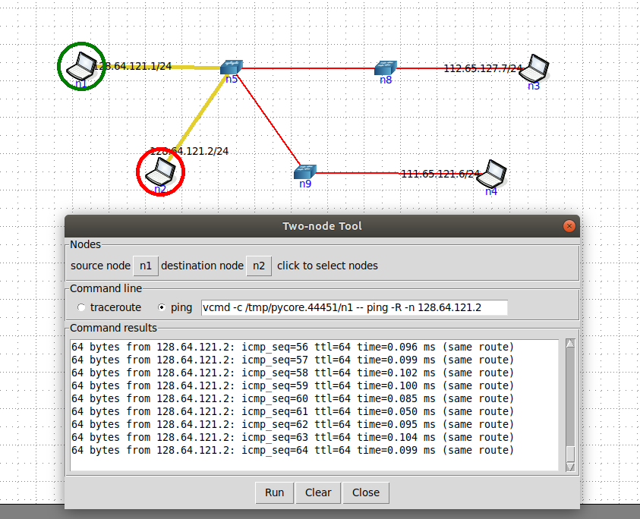
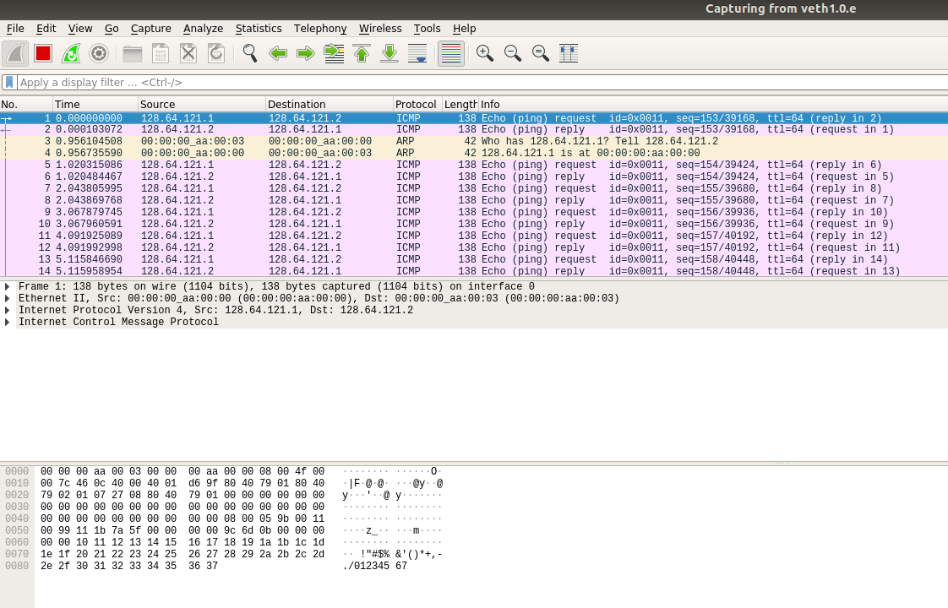
Между компьютерами из разных подсетей ping не проходит.
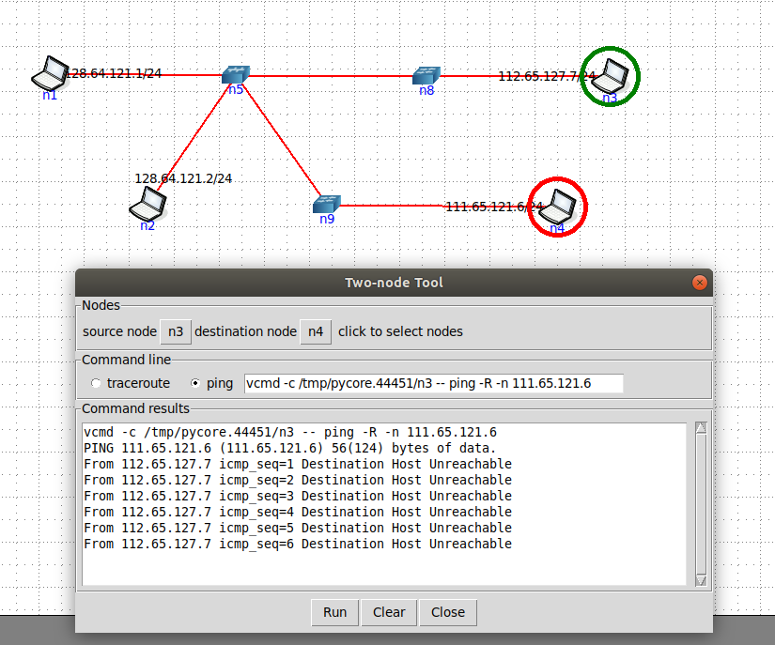

Список виртуальных интерфейсов:
b.5.e: flags=4163<UP,BROADCAST,RUNNING,MULTICAST> mtu 1500
inet6 fe80::bc02:a1ff:fe13:fbe2 prefixlen 64 scopeid 0x20<link>
ether 02:4e:41:36:ae:1e txqueuelen 1000 (Ethernet)
RX packets 101 bytes 10649 (10.6 KB)
RX errors 0 dropped 0 overruns 0 frame 0
TX packets 18 bytes 2363 (2.3 KB)
TX errors 0 dropped 0 overruns 0 carrier 0 collisions 0

b.8.e: flags=4163<UP,BROADCAST,RUNNING,MULTICAST> mtu 1500
inet6 fe80::1491:45ff:feb8:4d5 prefixlen 64 scopeid 0x20<link>
ether 5a:04:05:31:b5:65 txqueuelen 1000 (Ethernet)
RX packets 100 bytes 10557 (10.5 KB)
RX errors 0 dropped 0 overruns 0 frame 0
TX packets 17 bytes 2293 (2.2 KB)
TX errors 0 dropped 0 overruns 0 carrier 0 collisions 0

b.9.e: flags=4163<UP,BROADCAST,RUNNING,MULTICAST> mtu 1500
inet6 fe80::2c61:46ff:fe93:d978 prefixlen 64 scopeid 0x20<link>
ether 92:96:c0:45:c9:c5 txqueuelen 1000 (Ethernet)
RX packets 96 bytes 10218 (10.2 KB)
RX errors 0 dropped 0 overruns 0 frame 0
TX packets 21 bytes 2684 (2.6 KB)
TX errors 0 dropped 0 overruns 0 carrier 0 collisions 0

enp0s3: flags=4163<UP,BROADCAST,RUNNING,MULTICAST> mtu 1500
inet 10.0.2.15 netmask 255.255.255.0 broadcast 10.0.2.255
inet6 fe80::202f:8eed:7fa5:fc15 prefixlen 64 scopeid 0x20<link>
ether 08:00:27:b9:a2:24 txqueuelen 1000 (Ethernet)
RX packets 20750 bytes 22661605 (22.6 MB)
RX errors 0 dropped 0 overruns 0 frame 0
TX packets 6307 bytes 717858 (717.8 KB)
TX errors 0 dropped 0 overruns 0 carrier 0 collisions 0

lo: flags=73<UP,LOOPBACK,RUNNING> mtu 65536
inet 127.0.0.1 netmask 255.0.0.0
inet6 ::1 prefixlen 128 scopeid 0x10<host>
loop txqueuelen 1000 (Локальная петля (Loopback))
RX packets 630 bytes 69584 (69.5 KB)
RX errors 0 dropped 0 overruns 0 frame 0
TX packets 630 bytes 69584 (69.5 KB)
TX errors 0 dropped 0 overruns 0 carrier 0 collisions 0

veth1.0.e: flags=4163<UP,BROADCAST,RUNNING,MULTICAST> mtu 1500
inet6 fe80::704d:a7ff:fe13:eb15 prefixlen 64 scopeid 0x20<link>
ether 72:4d:a7:13:eb:15 txqueuelen 1000 (Ethernet)
RX packets 7 bytes 586 (586.0 B)
RX errors 0 dropped 0 overruns 0 frame 0
TX packets 130 bytes 16254 (16.2 KB)
TX errors 0 dropped 0 overruns 0 carrier 0 collisions 0

veth2.0.e: flags=4163<UP,BROADCAST,RUNNING,MULTICAST> mtu 1500
inet6 fe80::4e:41ff:fe36:ae1e prefixlen 64 scopeid 0x20<link>
ether 02:4e:41:36:ae:1e txqueuelen 1000 (Ethernet)
RX packets 7 bytes 586 (586.0 B)
RX errors 0 dropped 0 overruns 0 frame 0
TX packets 119 bytes 15280 (15.2 KB)
TX errors 0 dropped 0 overruns 0 carrier 0 collisions 0

veth3.0.e: flags=4163<UP,BROADCAST,RUNNING,MULTICAST> mtu 1500
inet6 fe80::f012:5dff:fec7:aaef prefixlen 64 scopeid 0x20<link>
ether f2:12:5d:c7:aa:ef txqueuelen 1000 (Ethernet)
RX packets 7 bytes 586 (586.0 B)
RX errors 0 dropped 0 overruns 0 frame 0
TX packets 122 bytes 15546 (15.5 KB)
TX errors 0 dropped 0 overruns 0 carrier 0 collisions 0

veth4.0.e: flags=4163<UP,BROADCAST,RUNNING,MULTICAST> mtu 1500
inet6 fe80::c484:4cff:fe19:cbe6 prefixlen 64 scopeid 0x20<link>
ether c6:84:4c:19:cb:e6 txqueuelen 1000 (Ethernet)
RX packets 7 bytes 586 (586.0 B)
RX errors 0 dropped 0 overruns 0 frame 0
TX packets 126 bytes 15898 (15.8 KB)
TX errors 0 dropped 0 overruns 0 carrier 0 collisions 0

veth5.8.e: flags=4163<UP,BROADCAST,RUNNING,MULTICAST> mtu 1500
inet6 fe80::f461:b1ff:fe2f:6c22 prefixlen 64 scopeid 0x20<link>
ether f6:61:b1:2f:6c:22 txqueuelen 1000 (Ethernet)
RX packets 42 bytes 5293 (5.2 KB)
RX errors 0 dropped 0 overruns 0 frame 0
TX packets 93 bytes 11371 (11.3 KB)
TX errors 0 dropped 0 overruns 0 carrier 0 collisions 0

veth5.9.e: flags=4163<UP,BROADCAST,RUNNING,MULTICAST> mtu 1500
inet6 fe80::5cdb:2cff:feb5:1f5c prefixlen 64 scopeid 0x20<link>
ether 5e:db:2c:b5:1f:5c txqueuelen 1000 (Ethernet)
RX packets 45 bytes 5598 (5.5 KB)
RX errors 0 dropped 0 overruns 0 frame 0
TX packets 89 bytes 10976 (10.9 KB)
TX errors 0 dropped 0 overruns 0 carrier 0 collisions 0

veth8.5.e: flags=4163<UP,BROADCAST,RUNNING,MULTICAST> mtu 1500
inet6 fe80::5804:5ff:fe31:b565 prefixlen 64 scopeid 0x20<link>
ether 5a:04:05:31:b5:65 txqueuelen 1000

(Ethernet)
RX packets 93 bytes 11371 (11.3 KB)
RX errors 0 dropped 0 overruns 0 frame 0
TX packets 42 bytes 5293 (5.2 KB)
TX errors 0 dropped 0 overruns 0 carrier 0 collisions 0

veth9.5.e: flags=4163<UP,BROADCAST,RUNNING,MULTICAST> mtu 1500
inet6 fe80::9096:c0ff:fe45:c9c5 prefixlen 64 scopeid 0x20<link>
ether 92:96:c0:45:c9:c5 txqueuelen 1000 (Ethernet)
RX packets 89 bytes 10976 (10.9 KB)
RX errors 0 dropped 0 overruns 0 frame 0
TX packets 45 bytes 5598 (5.5 KB)
TX errors 0 dropped 0 overruns 0 carrier 0 collisions 0

